**Technical Questions**

**Part 1: Code Review and Refactoring (30%)**

**Task 2**

**Task 3**

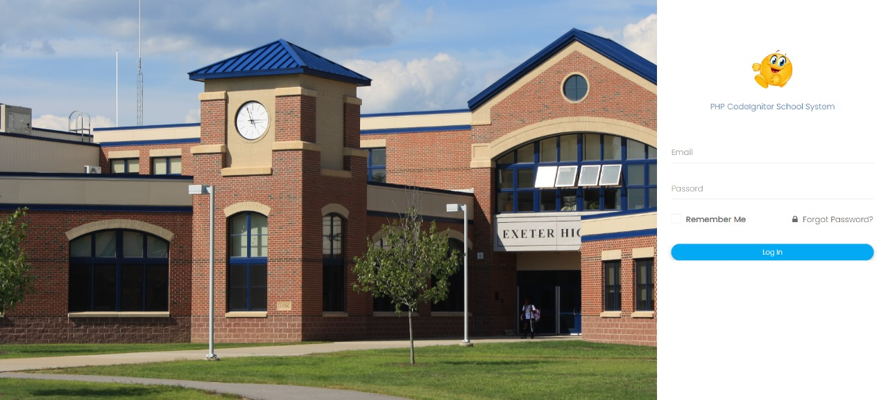

**Task 4**

**Task 5**

**Part 2: Feature Enhancement (40%)**

**Task 6**

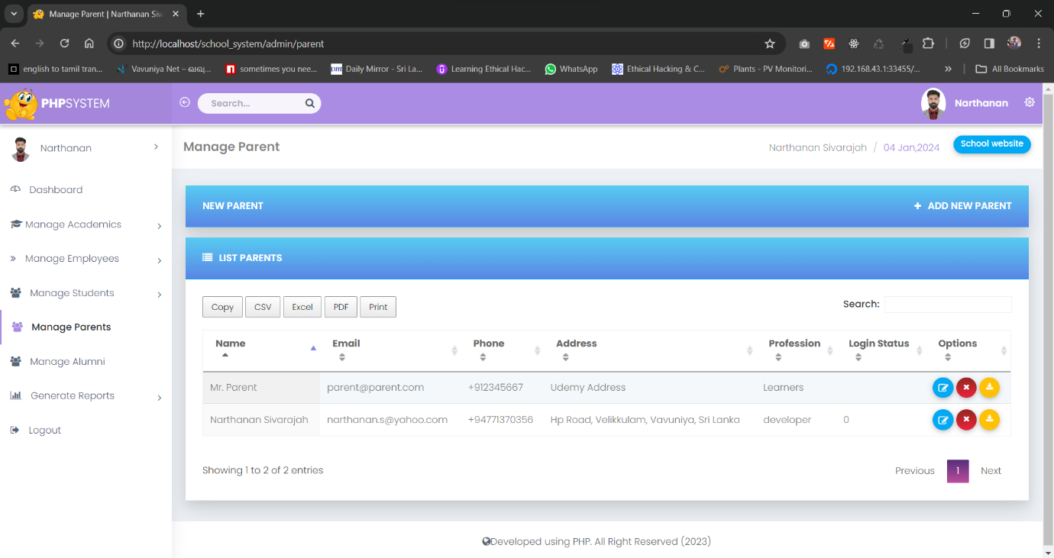

**Task 7**

